Firmware programming procedure
It is possible to change the firmware of the Board using this procedure:
1. Unplug general supply
2. Connect the USB
3. Launch WeerocUSB and go to the firmware section
4. Scan USB and Verify EPCS (result should be EPCQ128)
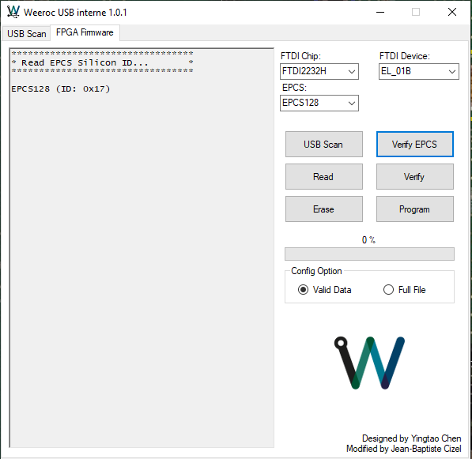

5. Click Program and choose the rpd file.
6. Wait for the Program to finish updating the rpd.
7. Unplug USB connector.
8. Plug general supply
9. Plug USB
10. Connect to the Evaluation board software
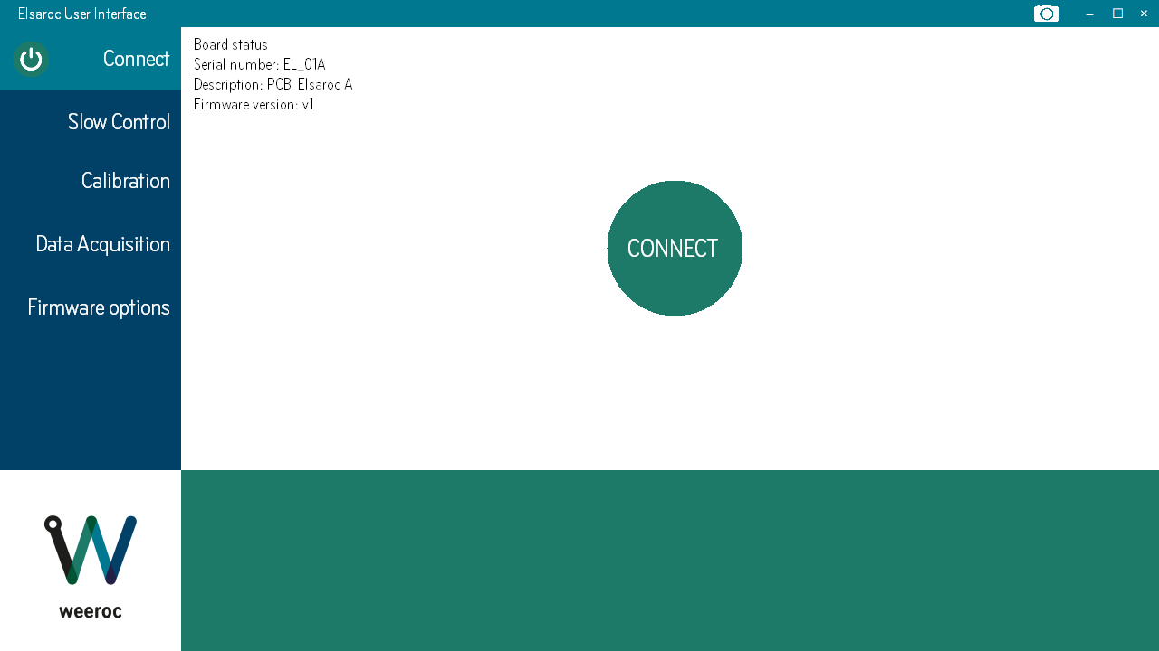
If the board is not well programmed, the connect button will turn to ted and the user will need to program the board again.

